**Batch: D - 1 Roll No.: 1601022096**

**Experiment / assignment / tutorial No. 02**

**Grade: AA / AB / BB / BC / CC / CD /DD**

**Signature of the Staff In-charge with date**

|  |
| --- |
| Title: Implementation of react concept |

**AIM:** To demonstrate the working of React.

**Problem Definition:**

Demonstrate the use of different concept of React on the basis of following points

1. Function Component
2. Styling/ Bootstrap
3. React JSX
4. Expressions in JSX
5. React Props
6. React state
7. React Component Lifecycle
8. React Events
9. Event Binding

**_____________________________________________________________________**

Expected OUTCOME of Experiment:

. **_____________________________________________________________________**

**Books/ Journals/ Websites referred:**

1. Express .js Deep API reference, by Azat Marden, Apress, 2nd edition, 2015.
2. <https://codeburst.io/building-a-rest-api-using-mongo-db-75cac3403fab>
3. <https://www.edureka.co/blog/rest-api-with-node-js/>
4. <https://bezkoder.com/node-express-mongodb-crud-rest-api/>

**Implementation Details:**

import React, { useState, useEffect } from 'react';

import './UserProfile.css';

function UserProfile(props) {

  const [clickCount, setClickCount] = useState(0);

  const [currentDate, setCurrentDate] = useState(new Date().toLocaleDateString());

  useEffect(() => {

    const interval = setInterval(() => {

      setCurrentDate(new Date().toLocaleDateString());

    }, 1000);

    return () => clearInterval(interval);

  }, []);

  const handleClick = () => {

    setClickCount(clickCount + 1);

  };

  const { name, age } = props;

  return (

    <div className="container mt-4">

      <div className="card">

        <div className="card-body">

          <h1 className="card-title">User Profile</h1>

          <p className="card-text">Name: {name}</p>

          <p className="card-text">Age: {age}</p>

          <p className="card-text">Current Date: {currentDate}</p>

          <p className="card-text">Button clicked {clickCount} times</p>

          <button className="btn" onClick={handleClick}>Click Me</button>

        </div>

      </div>

    </div>

  );

}

export default UserProfile;

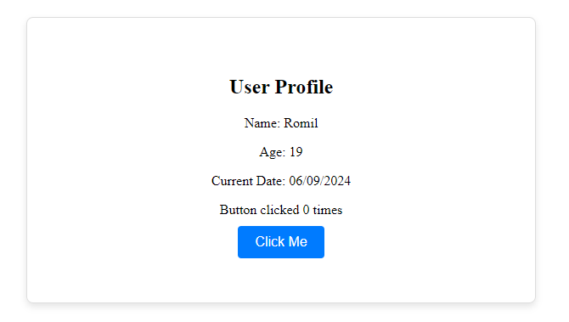 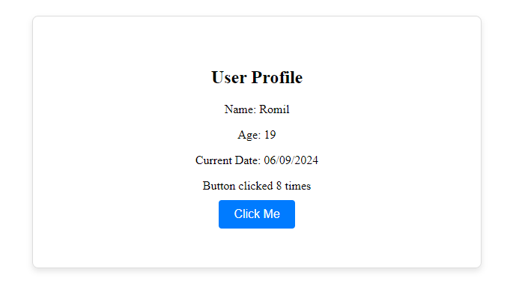

**Conclusion:**

This experiment effectively demonstrated various React concepts, including functional components, JSX, state, props, lifecycle, events, and styling.